Name: Venkatagiriraju U

NM Id: au611220104318

**Step 1: Uploading the Dataset**

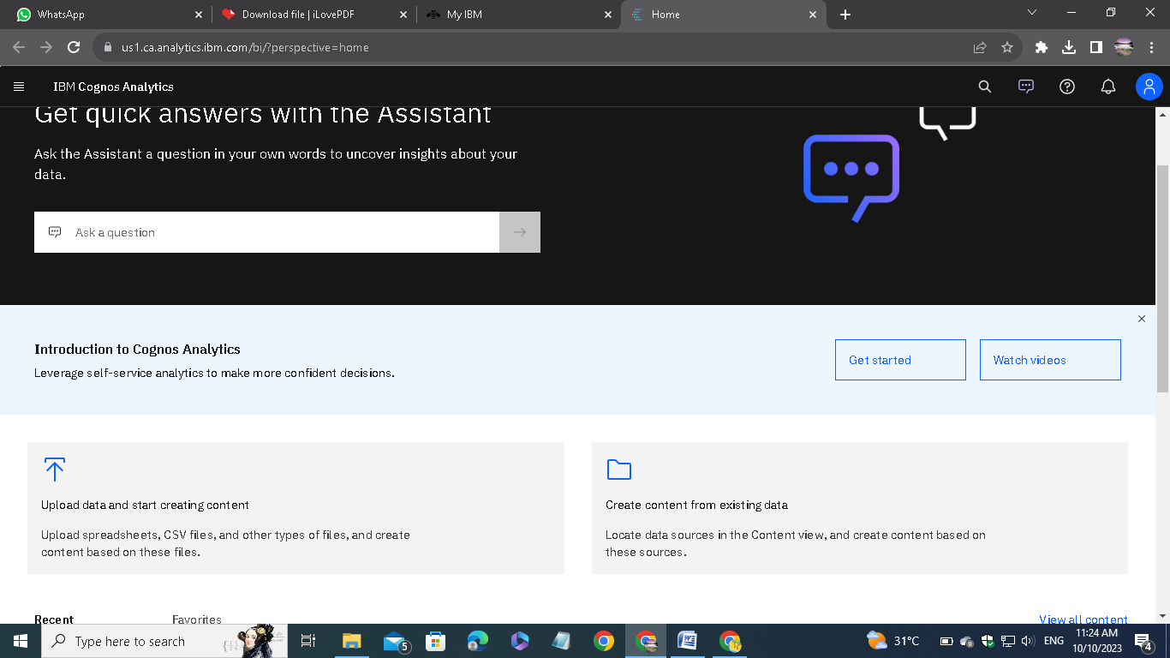

Open IBM Cognos Analytics. Then choose upload data.

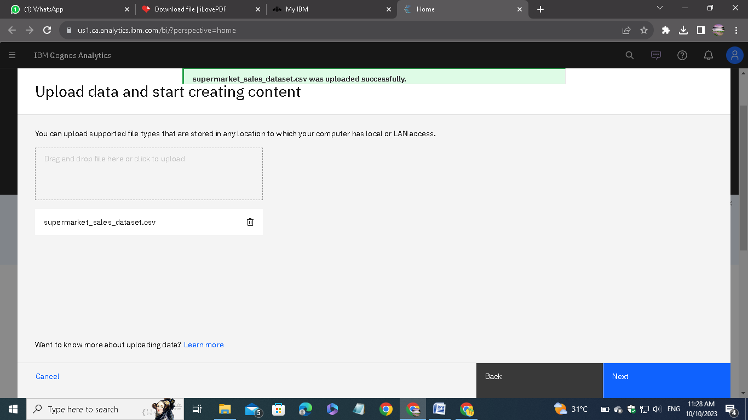

Upload the csv data file which we downloaded from the given link on the assignment.

# **Step 2: Preparing**

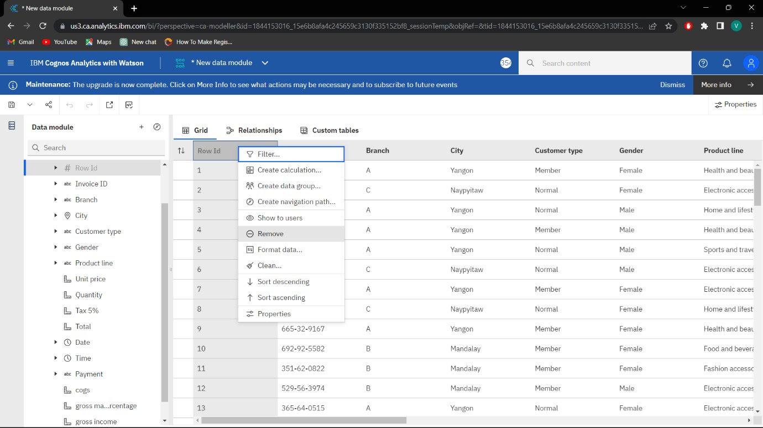

Remove the unnecessary columns and check for the missing values. In my case, there is no missing case.

After removing, save the new data module in a required name.

# **Step 3: Exploring**

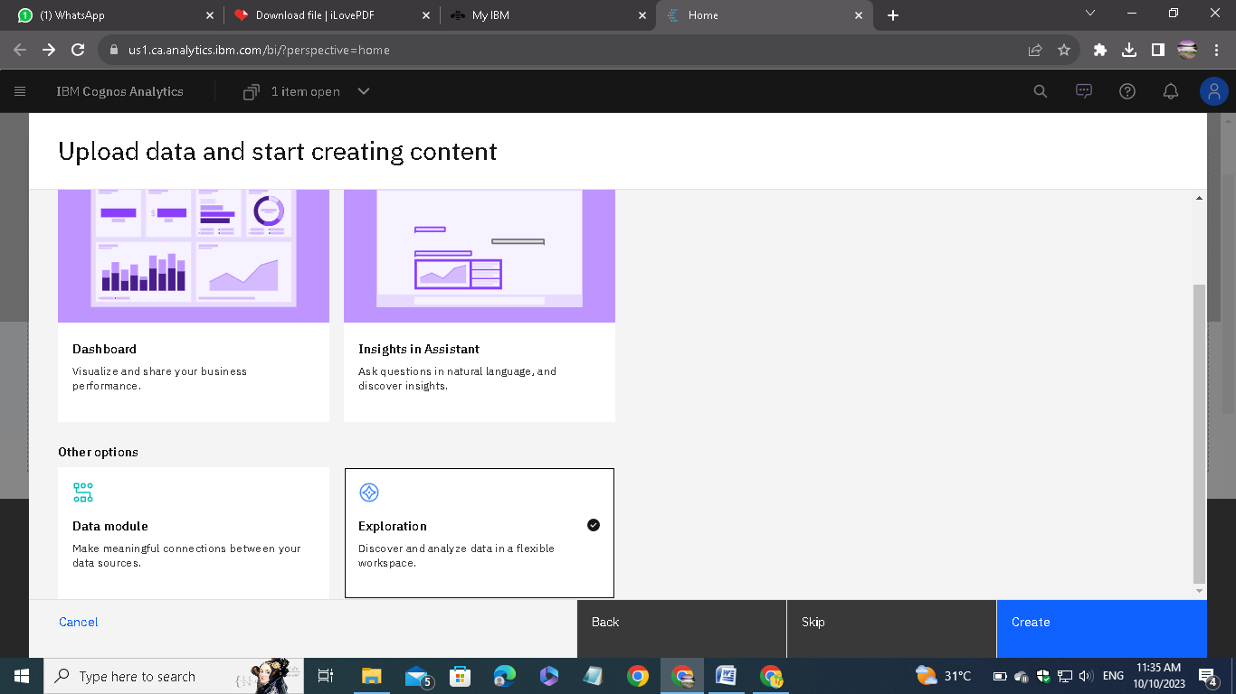

Go to explorations given in the menu and open the saved data module.

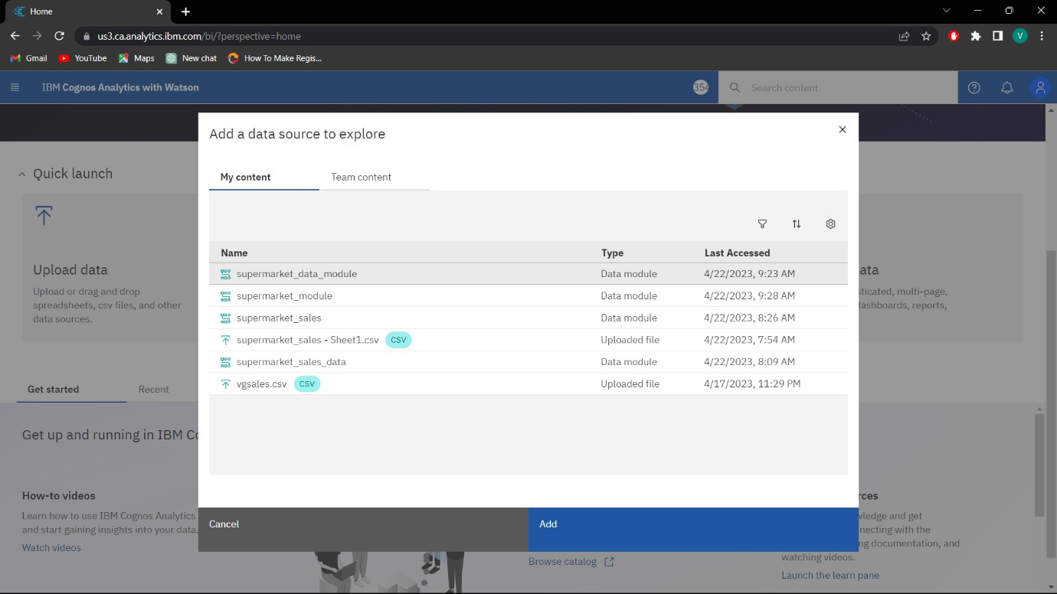

Then add the data module to the explorations.

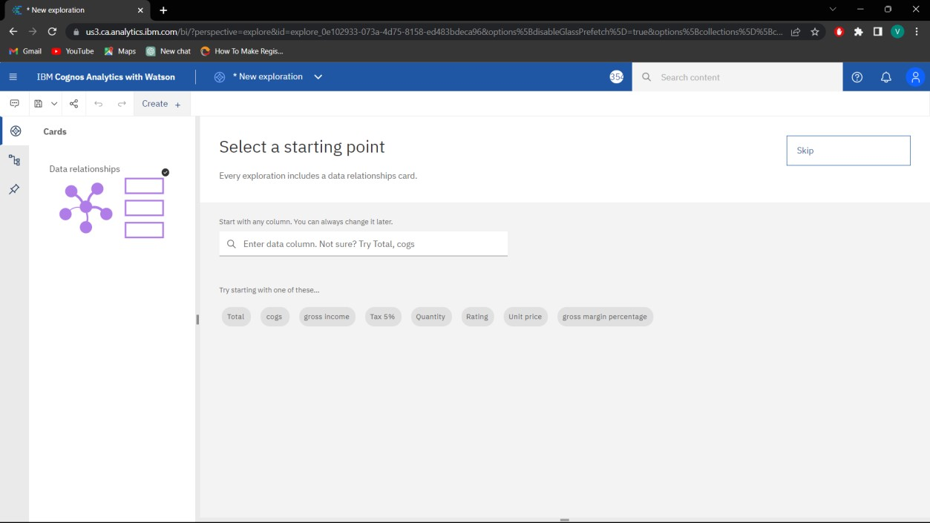

Click on create and choose the exploration style. In my case, I have chosen the single.

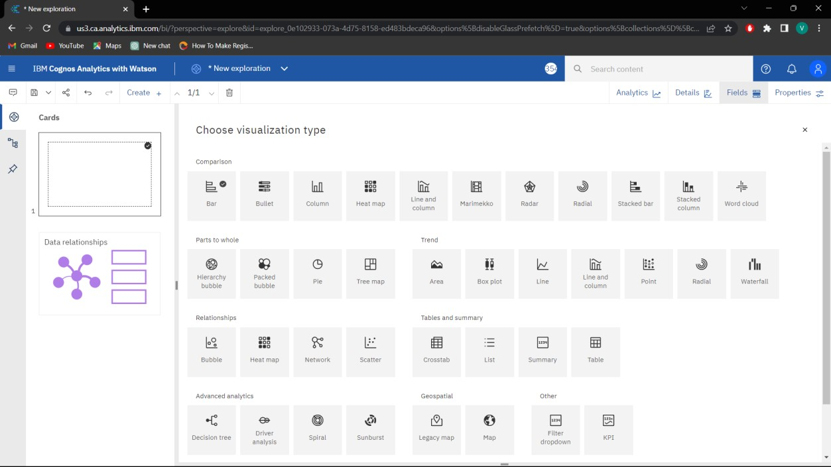

Then choose the type of the visualization. Each type of visualization is used for different needs.

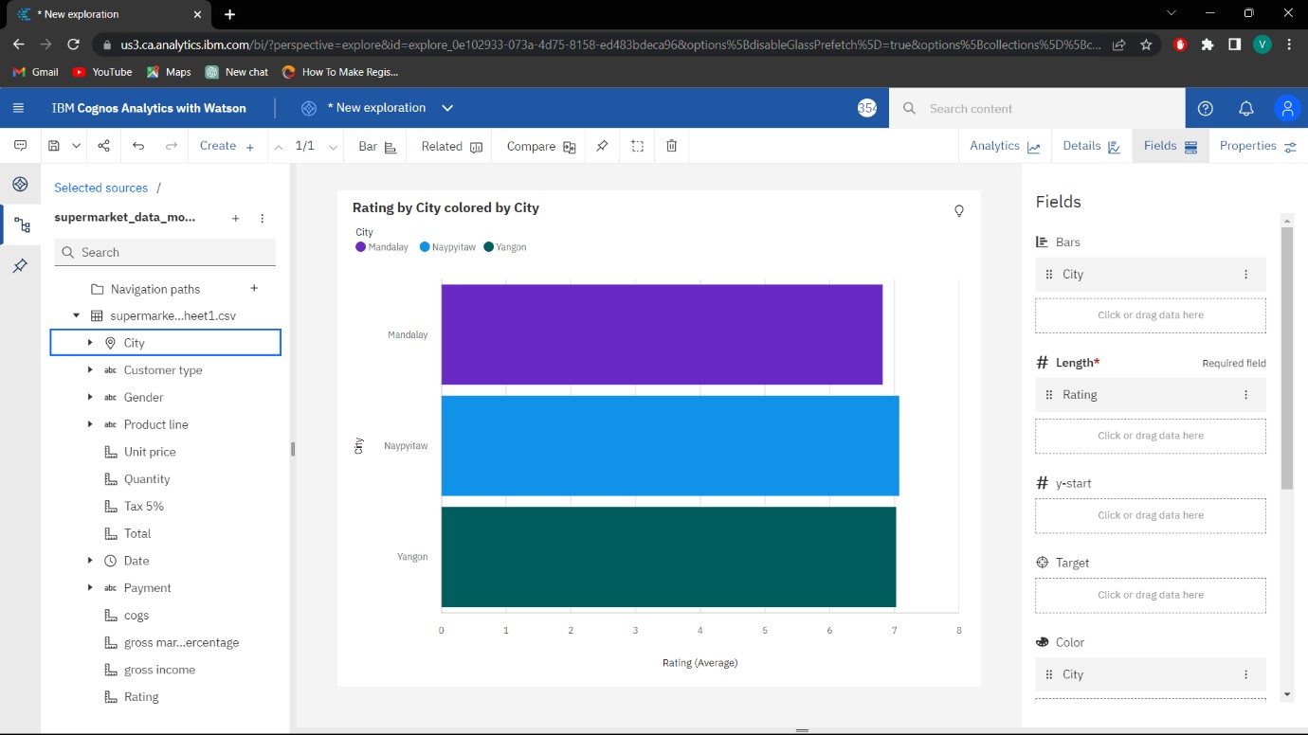

In the fields, we have to mention the attributes for the x-axis, y-axis and colors.

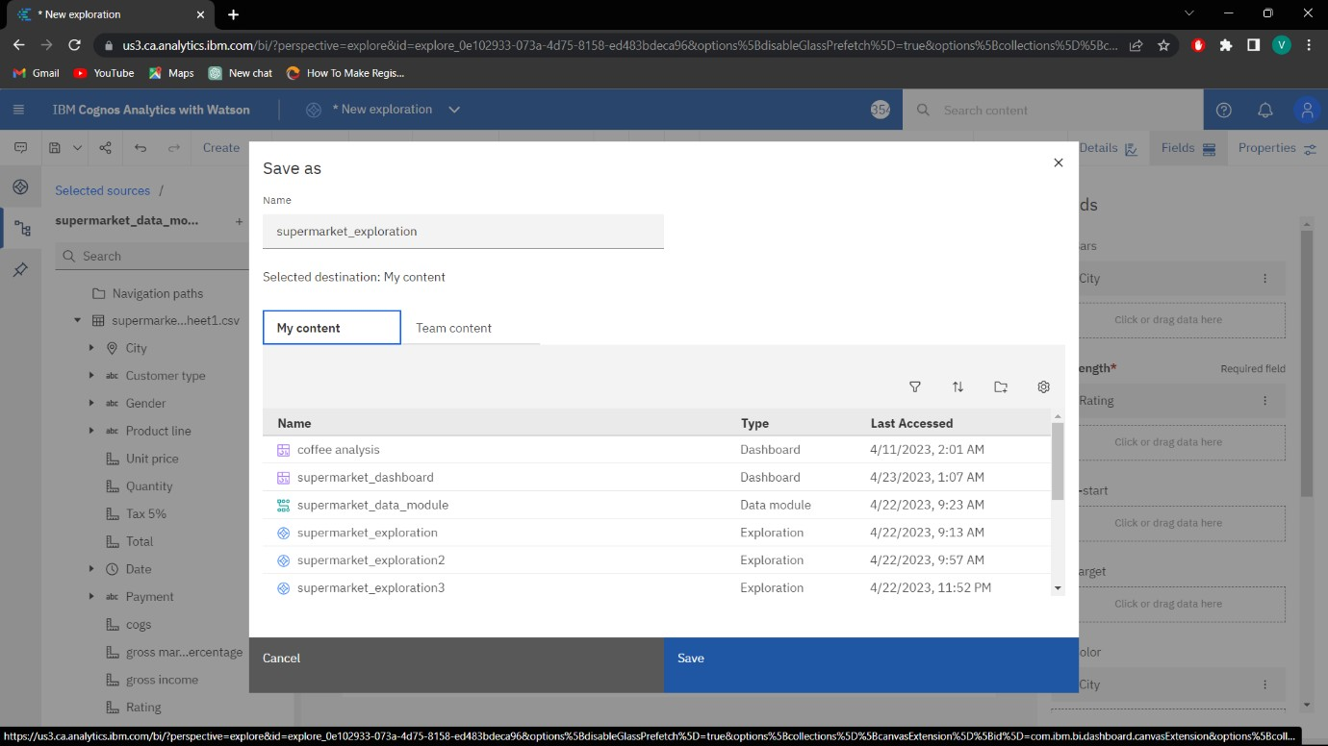

After exploring save it in a required name.

# **Step 4: Presenting**

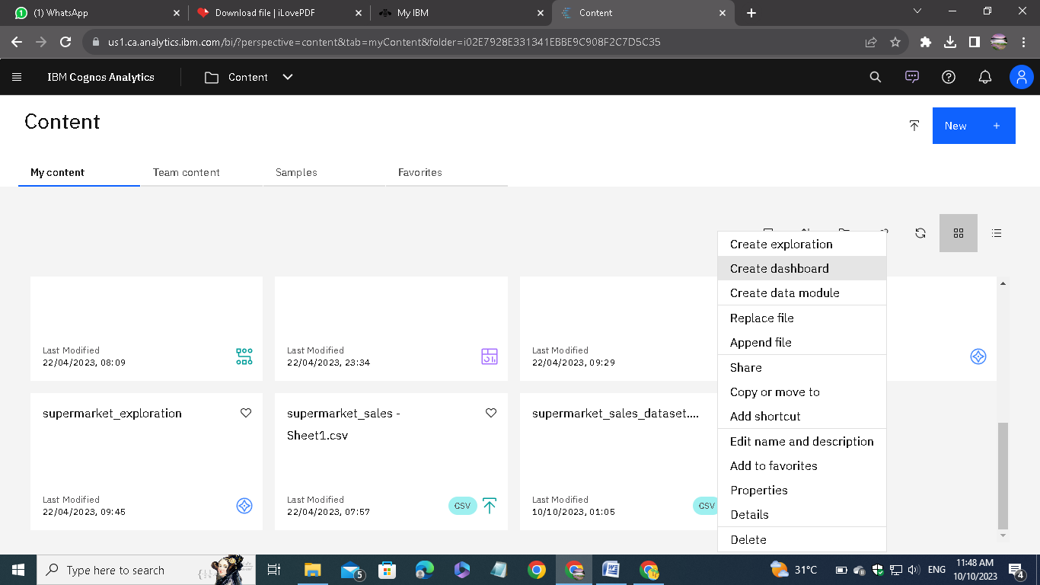

Choose create dashboard.

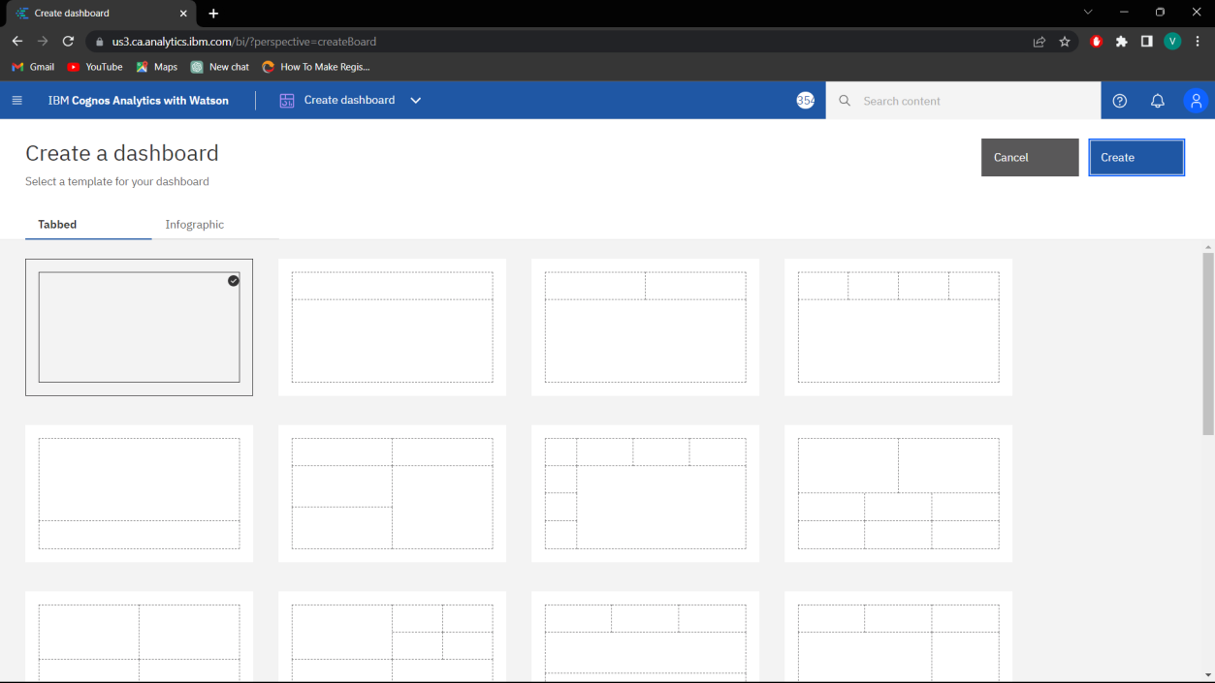

Choose the type of dashboard.

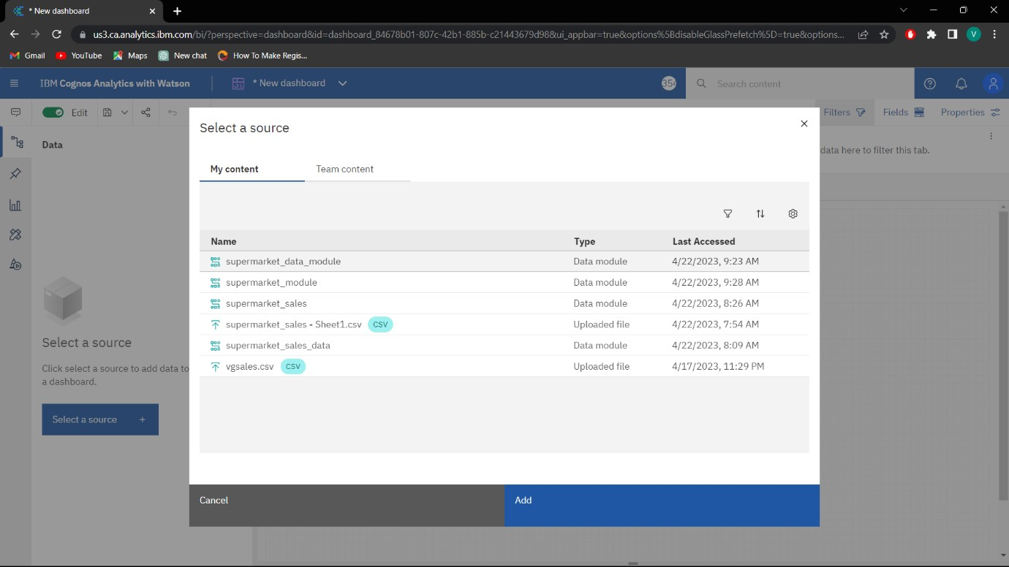

Add the source file to the dashboard.

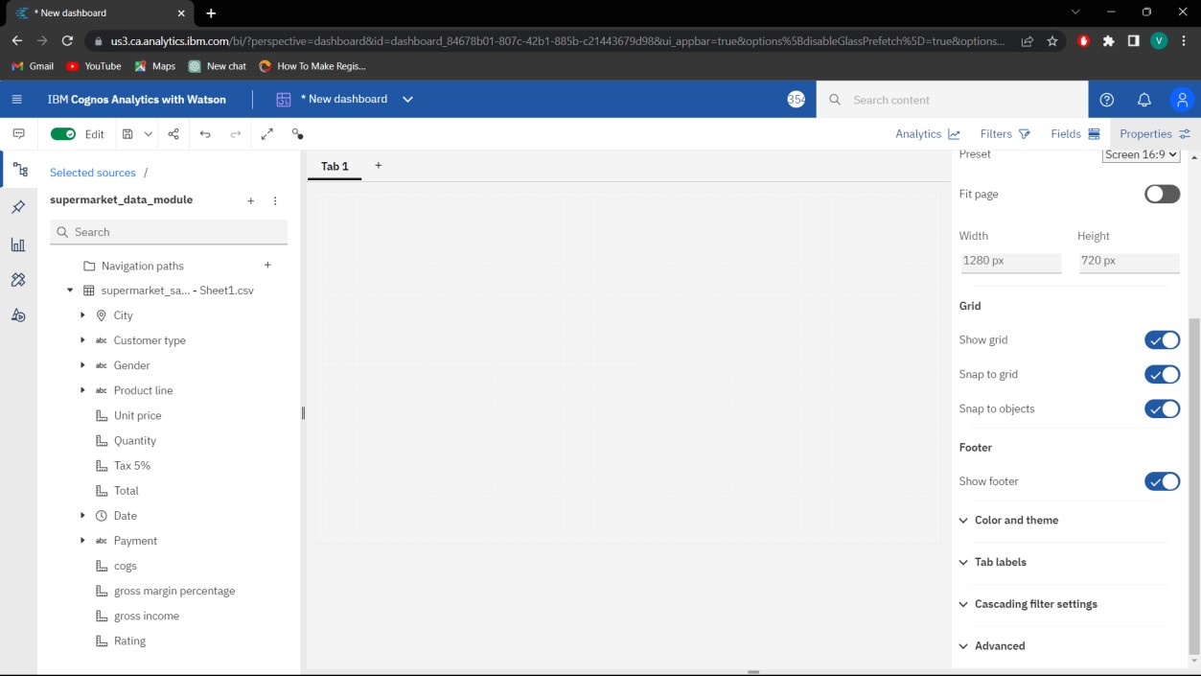

Adjust the dashboard settings for our convenience.

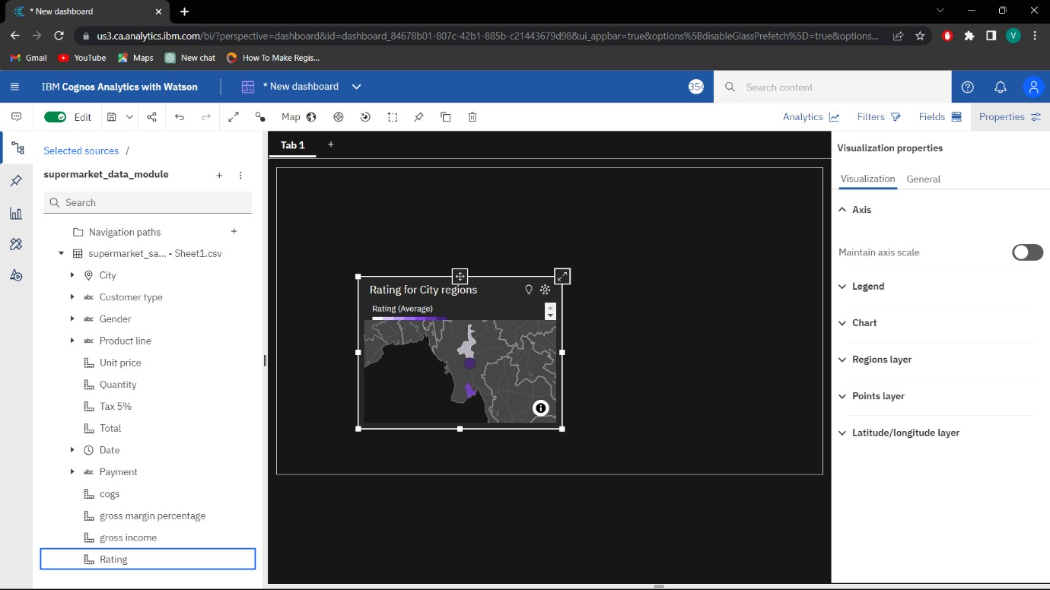

We can able to directly drag the data from the source or we can also able to plot our exploration directly from the pinned things.

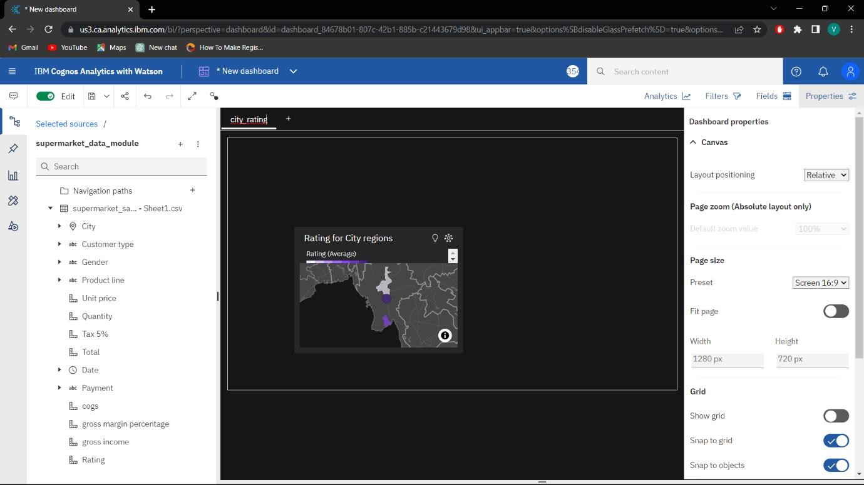

Change the tab name for our reference.

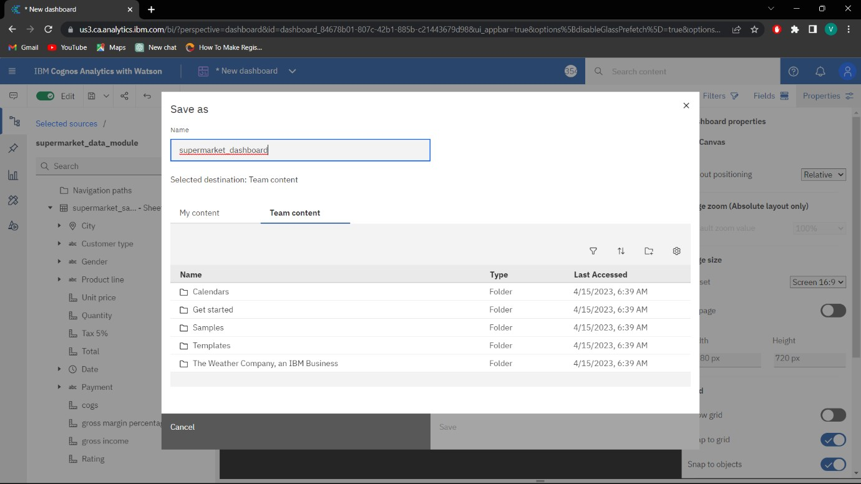

After that save the presentation. These steps are followed for all other tabs. Finally we get the visualization of our analytics.

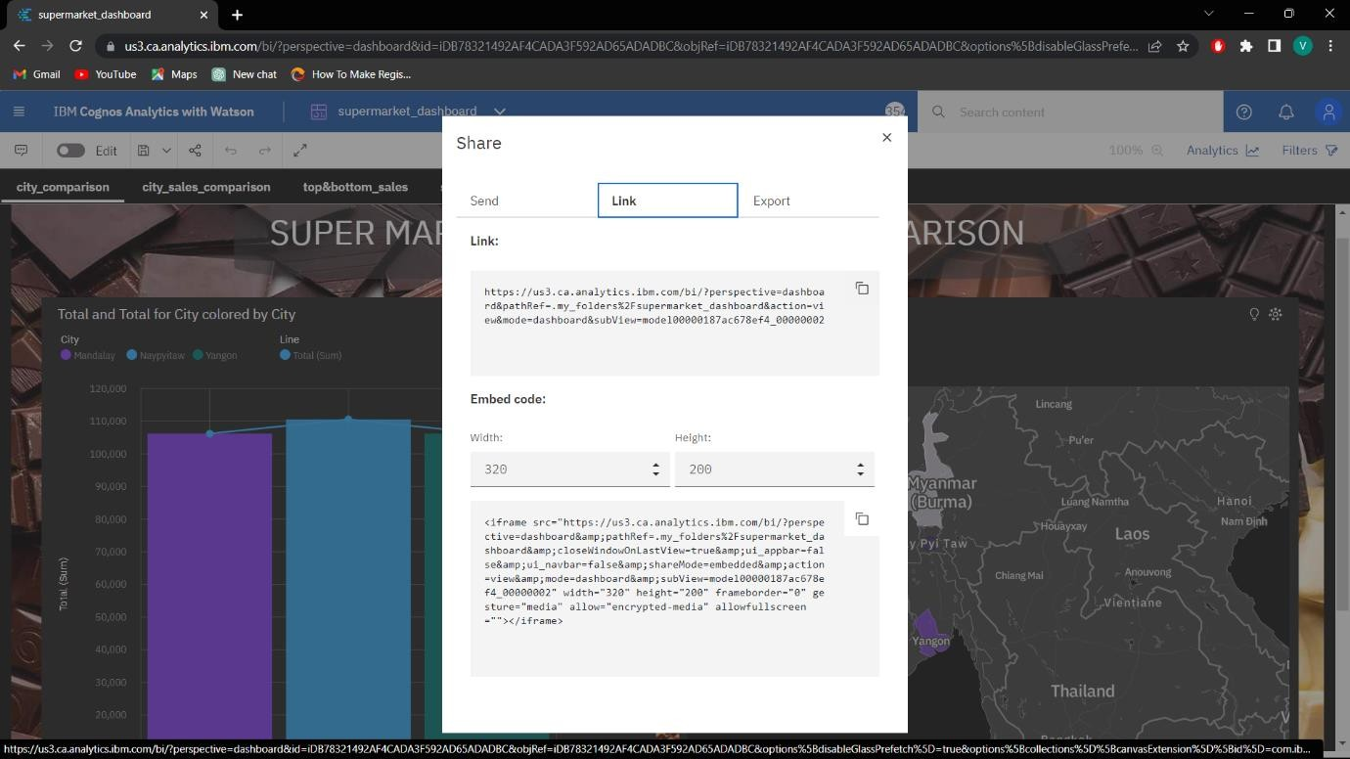

Using share option, we can able to share our presentation as direct link or the embed code.

Here I am attaching the screenshots of all the tabs I created:

